

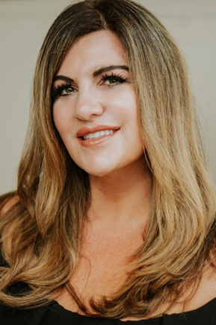

Hello neighbors!

My name is (first and last) and I’m your neighbor and a Realtor. I specialize in home sales and purchases, and I am available to assist with all your home buying or selling needs. If you are thinking of selling your house, this is the best time to do it (There is a smaller supply than demand), or if you think of buying an investment property, this is also a great time to do so, due to the low interest rate exist in the loan market. I will be happy to answer your questions and provide you with a guidance before putting the house on the market to get the best price, to advise you on the preparations required prior to purchasing a house and for a smooth transaction. As a resident of Brighton on the Bay, I’m familiar with appealing aspects of our neighborhood. Please call me if you are ready to get started or for any questions and I’ll appreciate if you will give my contact information to your friends and family.

Three Houses sold in the last year in our neighborhood

Address Sale Price

1769 Templeton Ln $935,320

1773 Templeton Ln $711,600

1860 Eden Way $800,000

Looking forward to hearing from you!!

Chantel Ray
757-717-1003
chantel@canzell.com

