HOW TO PROCESS COMMISSIONS:

We pay commissions every day! Check funds in the morning and throughout the day to make sure commissions are processed as soon as we have funds.

Step 1: Log into Chase using your token and open the Commissions account (7731)

Step 2: Screen shot (control-shift-4) any wires or checks that have been deposited and label them as the address on your desktop.
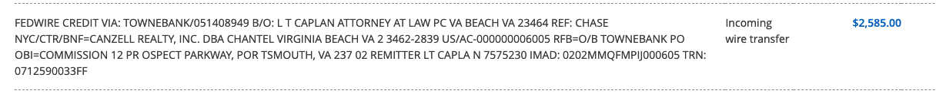

*If depositing checks using the Chase mobile app, make sure to write the address on the front of the check to easily match it to the transaction. Ex: 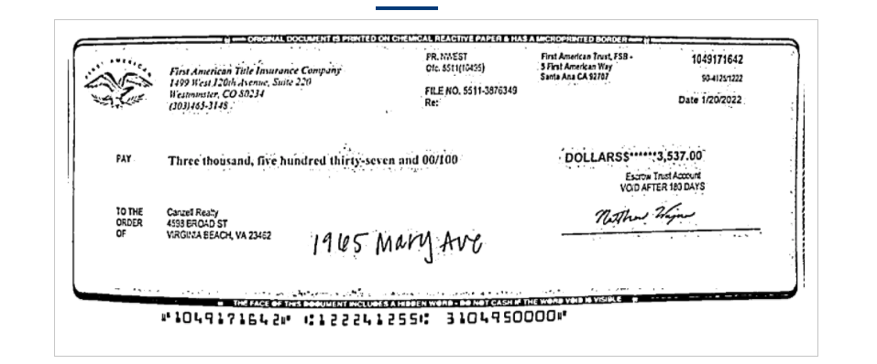.
Step 3: Ensure that the transaction is complete in Skyslope. Make sure that the final ALTA is attached and signed by all parties (If not, request from settlement company and cc agent). The transaction closing date and price must match the final ALTA.

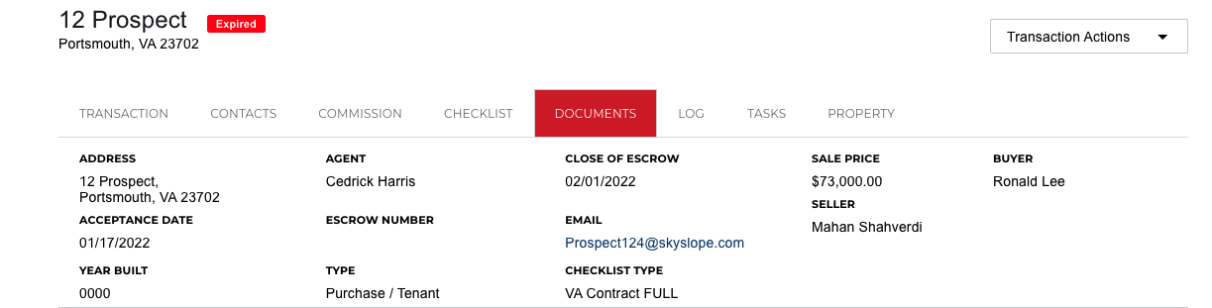
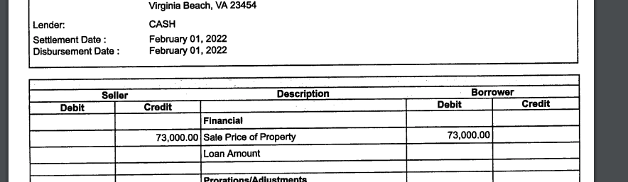

Step 4: Open the transaction in Brokermint and go to the commissions tab on the left

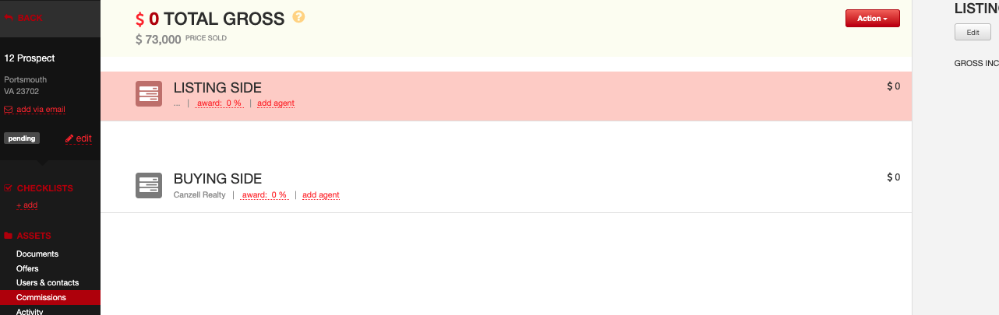

Step 5: Copy and Paste the address into your email search bar to pull up the commission form. (If one has not been submitted, call agent and request that they submit one).

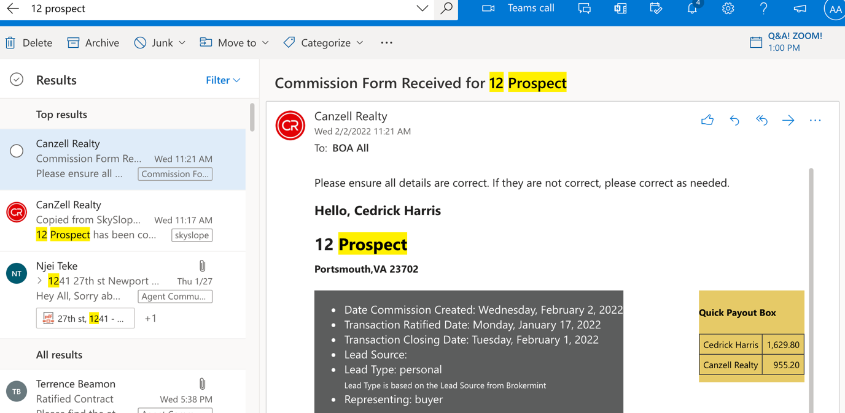

Step 6: Verify funds. Ensure that the total commission matches what we should have received on the ALTA. If the ALTA and commission form show that the $395 transaction fee was collected from the client, funds received should be Total Gross + $395.

See below and reference step 2 image: $2,109 + $395 (since it was collected) = $2,585. If the transaction fee shows agent paid, funds will match the total gross only.

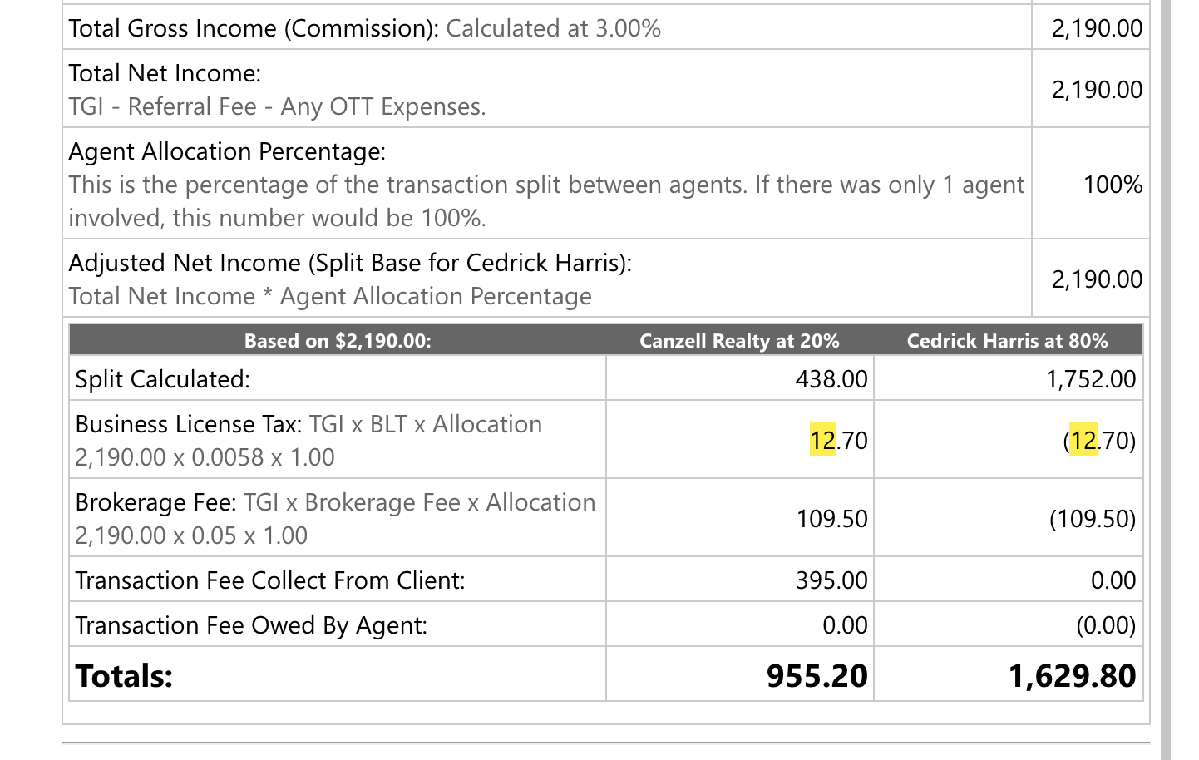

Step 7: Approve the commission form after confirming that it is correct. Scroll to the bottom of the form, hit approve and it will bring you to another screen to hit approve again.

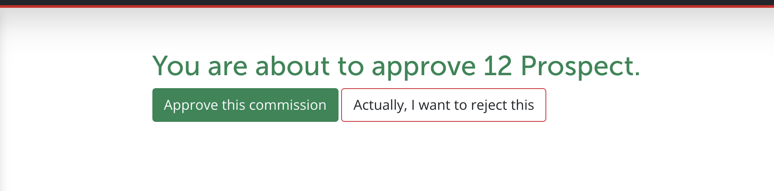

*This will send you an email of the approved form. Once you’ve received it, click the three dots on the top right, print, and save as PDF to your desktop labeled as the property address and commission form. EX: “12 Prospect commission form”

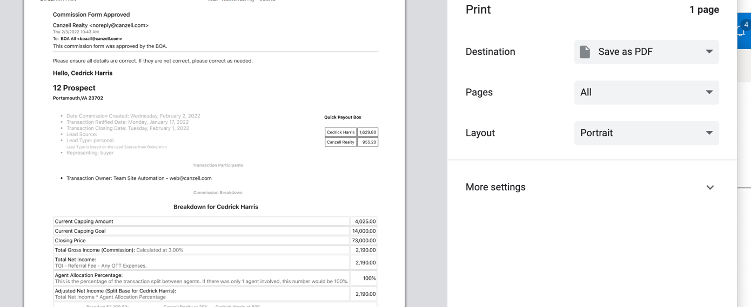

Step 8: Creating the CDA:

*Input total gross in Brokermint.
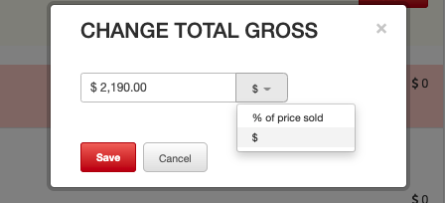

*Add agent to the buying side if we are representing the buyer, and the listing side if we are representing the seller.

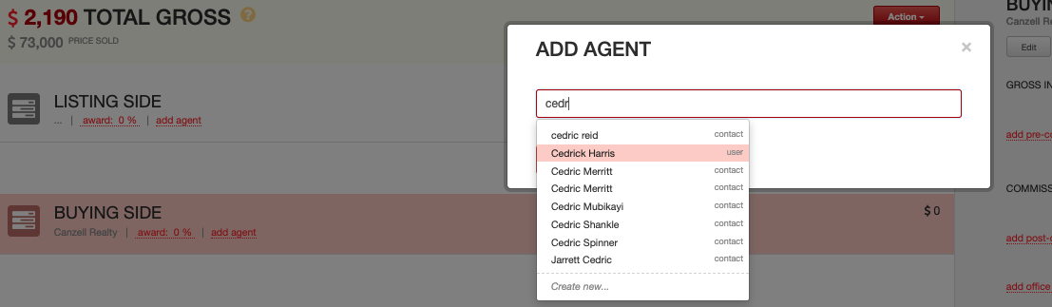

*Select the applicable commission plan. 100% will only be when the agent has capped, or it is a personal purchase/sale (only 4/year). A mentor would be shown on the commission form if that applies to the agent. APPT is when it is a company lead, and personal is when it is a personal lead.

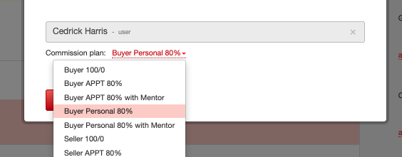

*Broker fees and BLT fees are shown on the commission form. They are added as post-split deductions and paid to the company side.

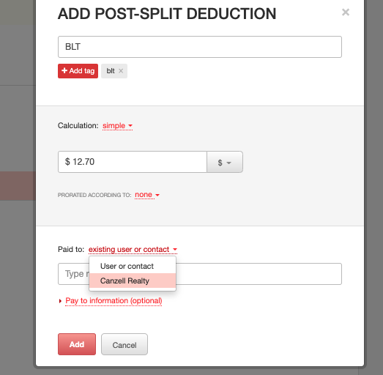
*Add transaction fee.

If paid by client: Click on the company side and add “other income”, label income as “transaction fee”, type in $395, and fill in the received from with who paid it.

+tag “transaction fee” AND +tag “$395 wire” if combined in total funds, OR +tag “$395 check” if a separate check/wire.

See ex:
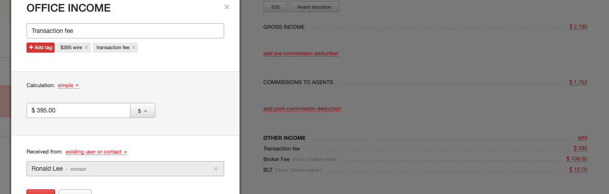

If paid by agent, add it as a post-split deduction on the agent side (just like Broker Fee and BLT), and pay to the company.

*Ensure that the payouts match the commission form and that all deductions and fees are accounted for. Once complete, click “action” on the top right, and “finalize commissions”

Click action again and generate CDA.

*Control P, save as PDF to desktop and label as the address and CDA.

EX: “12 Prospect CDA”

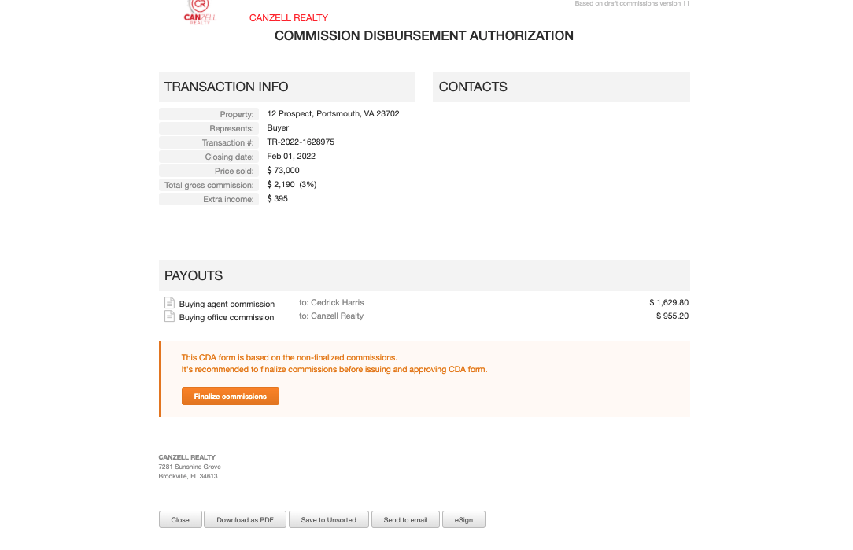

Step 9: Open Adobe and click on “Combine Files.” This is where you will create the final scan.

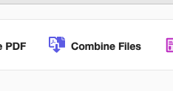
Add the 1. CDA, 2. Commission Form, and 3. Funds. Combine files in that order (can be reorganized in Adobe if needed). Save file as Address and commissions to desktop.

Ex: 12 Prospect commissions
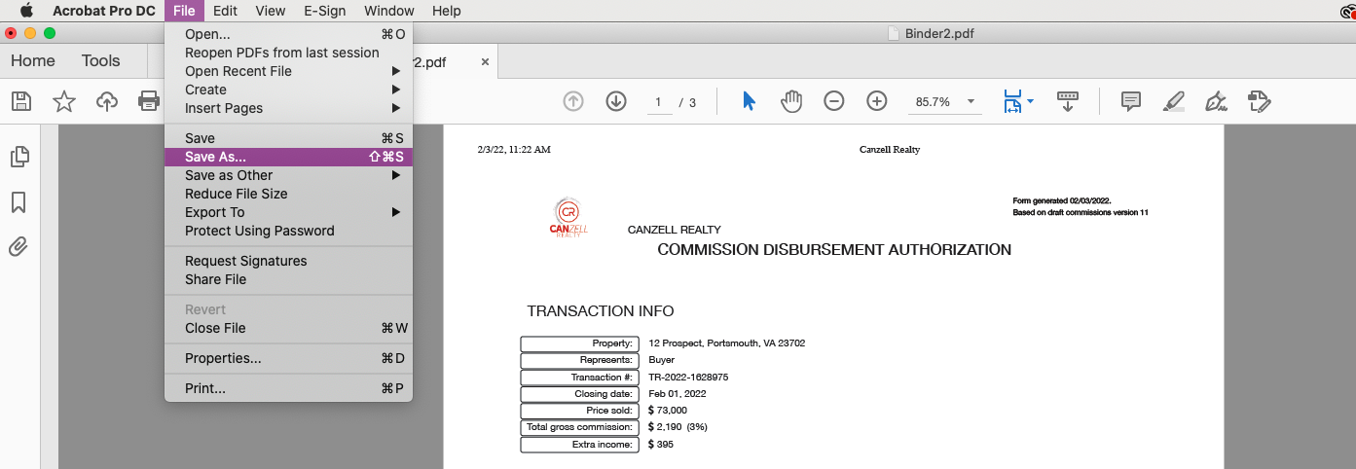

Step 10: Add final scan packet to Broekrmint and Skyslope and close out both verifying that the sales price and closing date is correct.

Step 11: Pay commission.

*Open QuickBooks. Go to Payroll on the left, and then contractors.

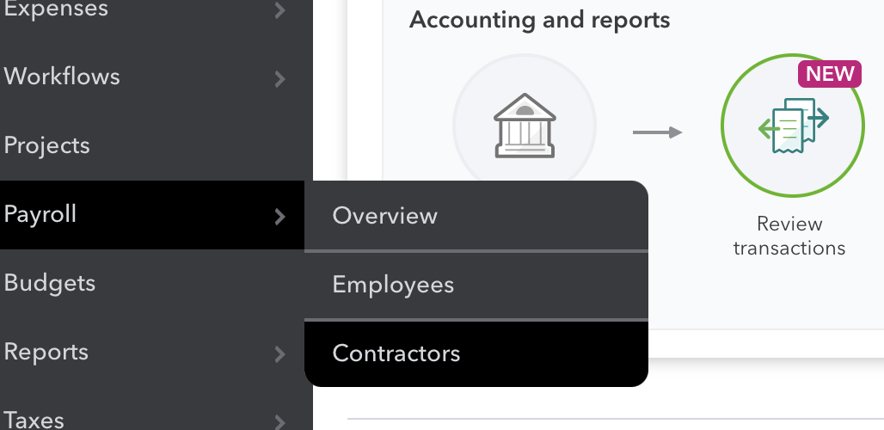

*Type in the agent’s name that you are paying and click “Pay with direct deposit” on the right.

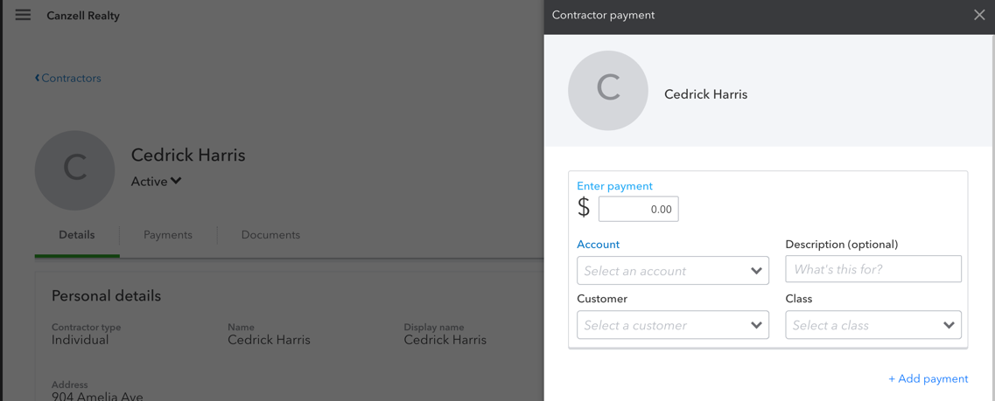
*Enter payment amount (from commission form).

*Enter account: “52010 Cost of Sales Revenue: Personal Sphere Commissions” if personal sphere lead, OR “51010 Cost of Sales Revenue: Company Generated Commissions” if company lead.

*Enter Location as “Corporate” and account in QB as “10380 Chase Commissions 7731”.

Verify information and click pay.

See ex:
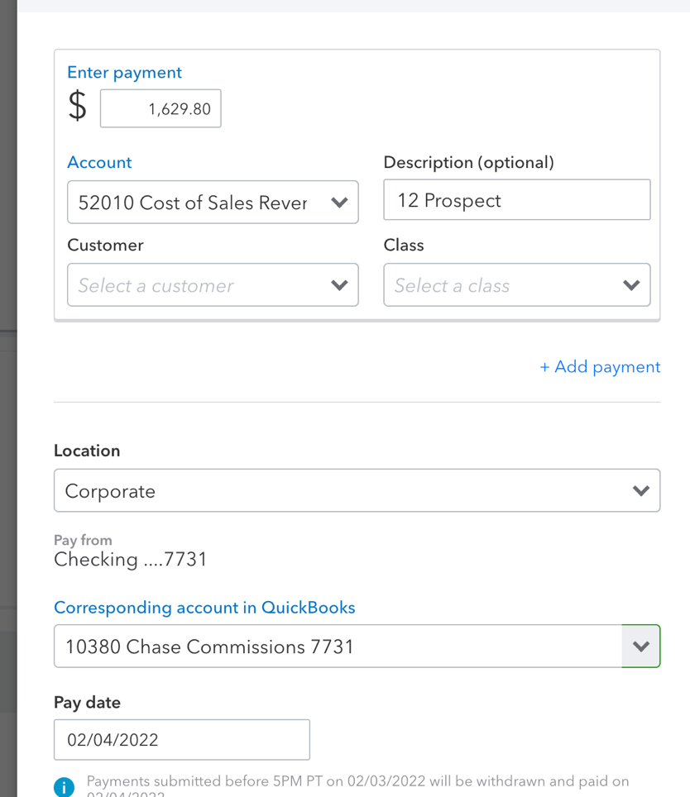

Make sure that confirmation from QuickBooks is shown. Ex:

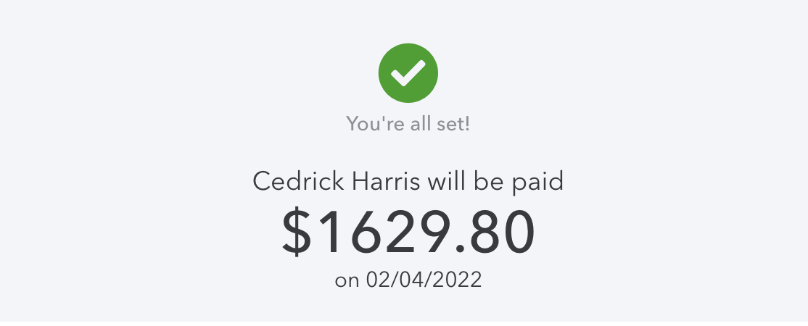

Step 12: Transfer Company Funds.

*Open Chase using your token, click on “Pay & Transfer” at the top. Click Transfer money.

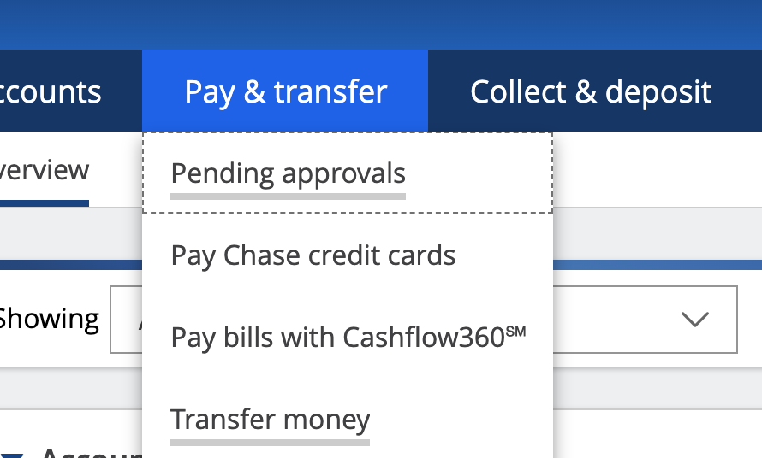

*Transfer from Commissions 7731 to Corporate 9328 and fill in the amount as the amount for Canzell shown on the final scan. Add the address in the memo line and hit next and transfer.

